Personal Information
Full Name:

Address:

City: Postal Code: Cell:

Home Phone Work Phone:

Occupation: Employer:

Date of Birth (M/D/Y): Care Card #:

Extended Medical Insurance Carrier:

Email Address (used strictly for appointment reminders by ONLY our office ):

Referred By: Doctor | Telus | Website | Drive-By | Friend (Please Include Name) | Other:

Medical History
Have you attended a doctor of chiropractic before? Yes | No

If yes, name of chiropractor:

How long ago:

Name of family MD: Phone #:

When did you first notice this condition:

Describe your present condition or symptoms:

Is this the result of an MVA or work-related injury? Yes | No

If yes, do you have a claim? WCB | ICBC

Are you taking any medications at present? Yes | No

If so specify:

Have you seen other health professionals for this present condition? Yes | No

Previous “history” of accidents / injuries / operations etc:

over page 2...

Show your areas of discomfort:

Circle: Pain | Discomfort 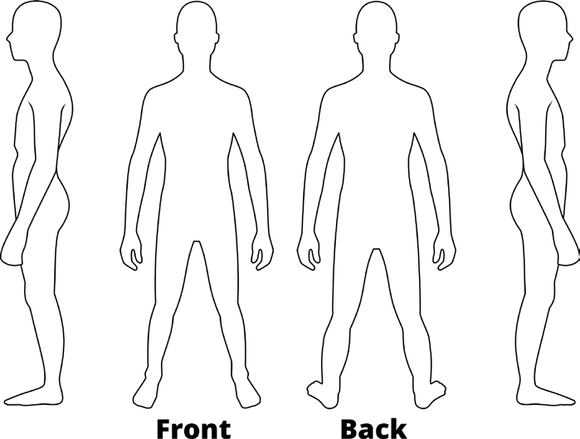

PATIENT – DOCTOR AGREEMENT:

PATIENTS ARE RESPONSIBLE FOR THEIR ACCOUNTS WITH PATERSON CHIROPRACTIC. PAYMENT IS DUE WHEN SERVICE IS RENDERED. IF YOU CANNOT FULFILL THE AGREEMENT MADE WITH US, PLEASE ADVISE US IMMEDIATELY SO NEW ARRANGEMENTS CAN BE MADE.

INITIAL EXAMINATION $ 75.00

RE-EXAMINATION (AFTER SIX MONTHS LAPSE) $ 65.00

REGULAR OFFICE VISITS $ 55.00

CHILDREN (BIRTH – 15 YEARS & FULL-TIME STUDENT/POST-SECONDARY $ 50.00

ADDITIONAL REHAB $ 35.00

**PATIENTS MUST GIVE TWENTY-FOUR HOURS (24HRS.) NOTICE OF CANCELLATION OR A FEE OF $35.00
WILL BE CHARGED.**

I UNDERSTAND AND AGREE TO ABIDE BY THE ABOVE STATED POLICIES WITHIN THIS OFFICE. I ALSO UNDERSTAND THAT FEES ARE DUE WHEN SERVICES ARE RENDERED, AND THAT I AM RESPONSIBLE FOR PAYMENT.

Patient’s signature: Date:

